Devans Checkout code snippet

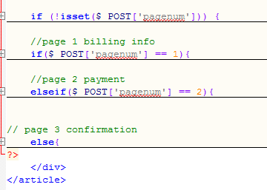

Im proud of this code because the checkout is actually only 1 “page” but it acts like 3! Using pagenum which is set to 1 at first, the if statement checks to see what number it is, since it starts at 1 it will display the first page. When you click submit on the first page, pagenum becomes set to 2 and the page refreshes, the if statement then goes to the elseif checking to see if pagenum is 2 which it is, it then displays page 2. After you pay with stripe pagenum is set to 3 which means the else statement at the end comes into effect showing the confirmation page.